NimbleMeet

A End-User guide

NimbleMeet is a platform for you to conduct all your meet ups, conferences, classes and video calls. This platform was built during Engage ’21. If you want to dive in directly and use the platform for all your video calls and communication, you can refer to this video.

**1. Entities in the application**

* User: For users to use the application they must sign up using an email. The email will be verified. The user can then host or join meetings they can also change their display name that will appear in the video calls and chats.
* Meetings: Any user can host or join a meeting. These meetings have an ID that is used to uniquely identify a meeting and can be used to join the corresponding meeting. Meetings also have a title (friendly name) and a scheduled time.
* Admin: Every meeting has admins and participants. The admins can change the meeting title and scheduled time. They can also add or remove the participants from the meeting.

**2. Features of NimbleMeet**

* Host and join a meeting.
* Add up to 20 participants.
* Chat in between calls.
* Schedule meetings.
* Restrict the meetings and have control over who can join it.
* Have a conversation before and after the meeting.
* a meeting logs to access all your meetings in one place.
* Responsive UI for all types of screens.
* Manage your user profile.
* When you open the website, you’ll be asked to login or sign up

UI and Guide

* + When you enter the application, you are required to sign up or login.
  + You can either use google login or use the classic method of sign up by entering an email and password

sign in screen


* Main screen
  + The main screen contains four options.
  + Start meeting – to initiate a meeting
  + All meetings – a log of all your meetings
  + User profile – shows the user details and allows to change his display name
  + Log out

* Host or join meet
  + You can choose to host or join a meeting.

* Join meeting
  + You can join a meeting by entering its ID if its not restricted.

* Host meeting
  + You can host a meeting.
  + The app will generate a random id for your meeting and you’ll have to enter a title.

* Schedule meeting
  + You can schedule a meeting by allotting a date and time to it.
  + Participants that have been added will be able to see scheduled meeting in their meeting scree.
  + If you make your meeting restricted, then nobody will be able to join the meeting unless and until you add them to the meeting.
  + you automatically become a admin of the meeting you created.

* All Meetings
  + All the meeting that you are a part of will appear here
  + The red ones are meetings in the past, blue ones are scheduled today and purple ones are scheduled for future

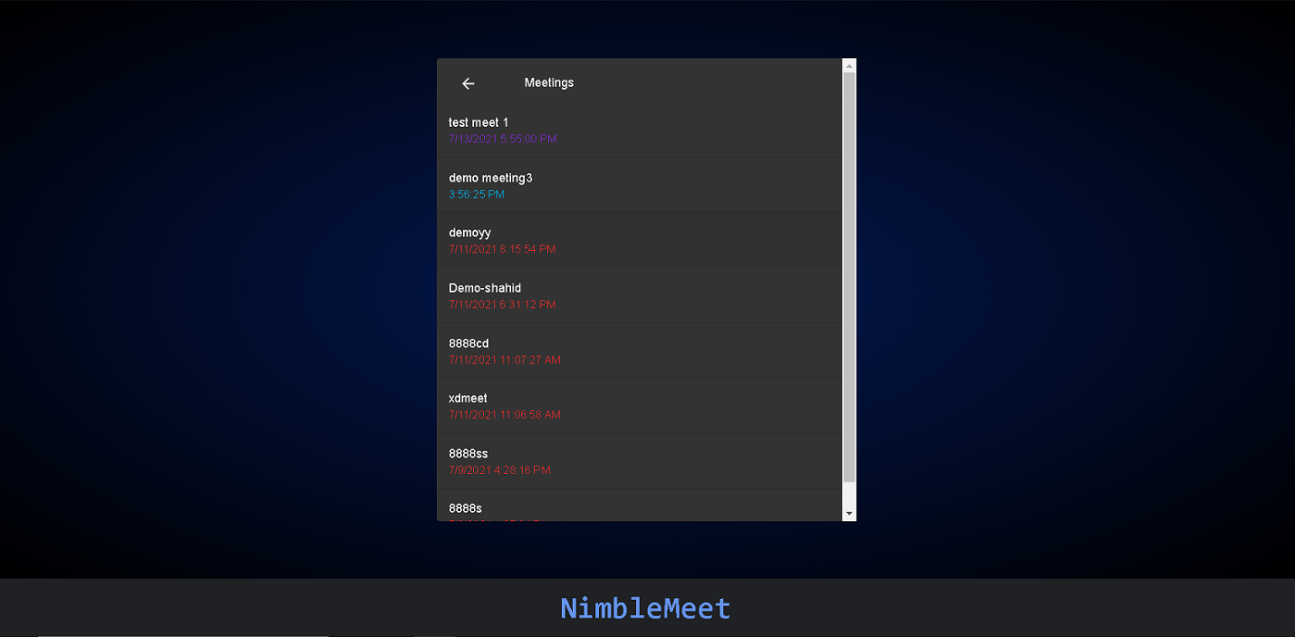

* Chats
  + Here you will find chats for a meeting that you can start before meeting, in the meeting and will be able to continue after the meeting.
  + You can click the video icon on upper right to enter this meeting.

* Meeting settings
  + If you are the admin of a meeting then you can change the meeting schedule, title and its restriction.

* Meeting participants
  + Here you’ll find all the meeting participants. If you are a admin you can remove anyone or make anyone a admin.

* Initiate call
  + Before you enter a call, you can check your video and your mic.
  + The audio bar will show your audio level.
  + You can also disable or enable mic / cam.

* Conference room

